Question 1:
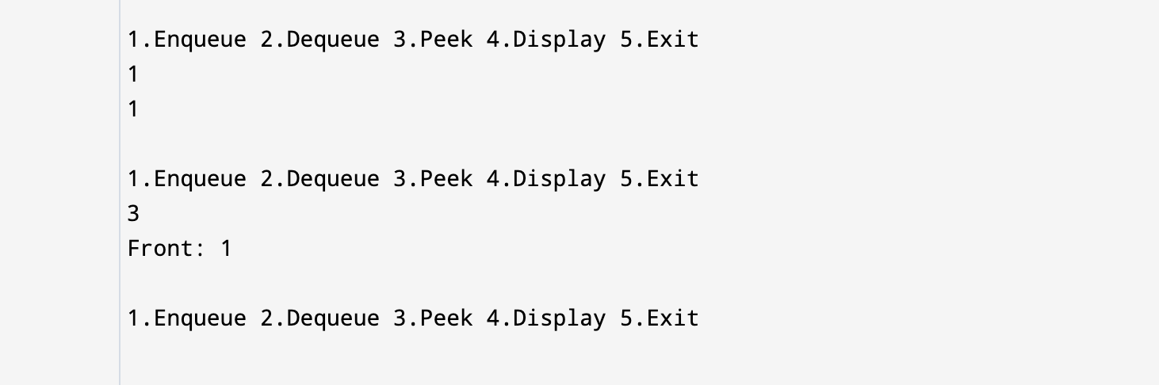

Question 2
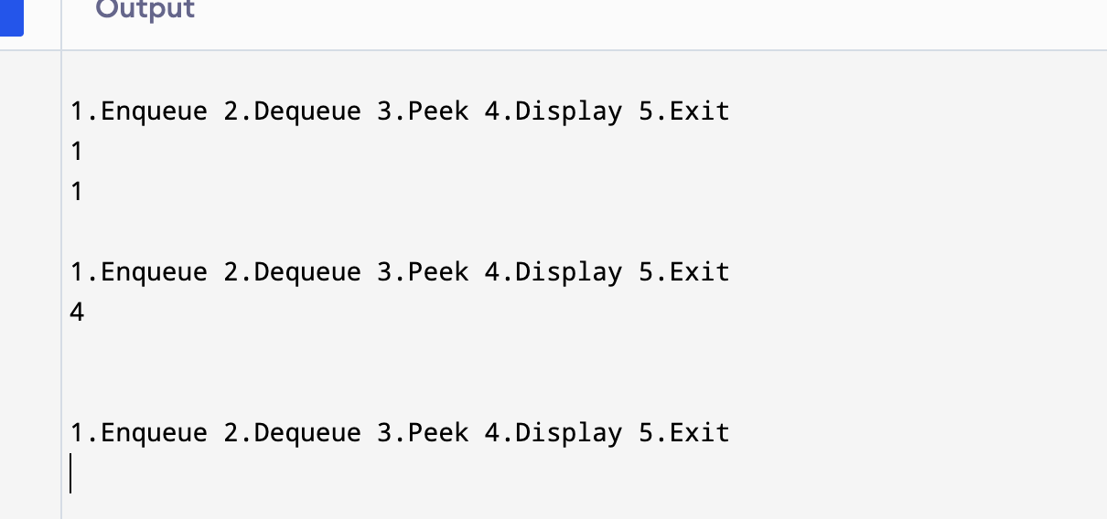

Question 3:
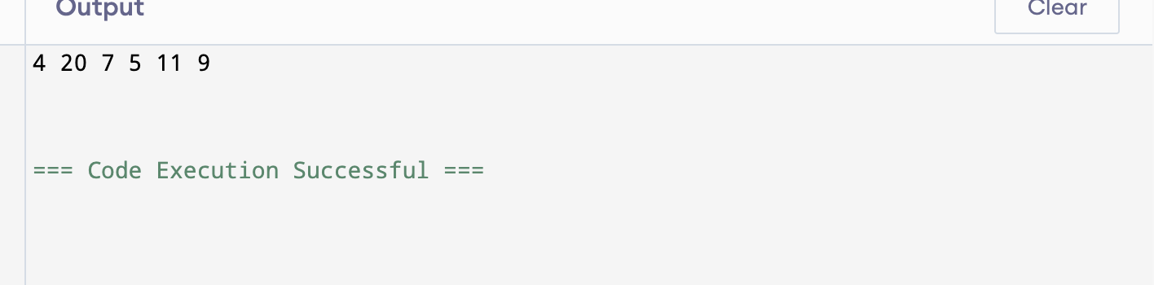

Question4: 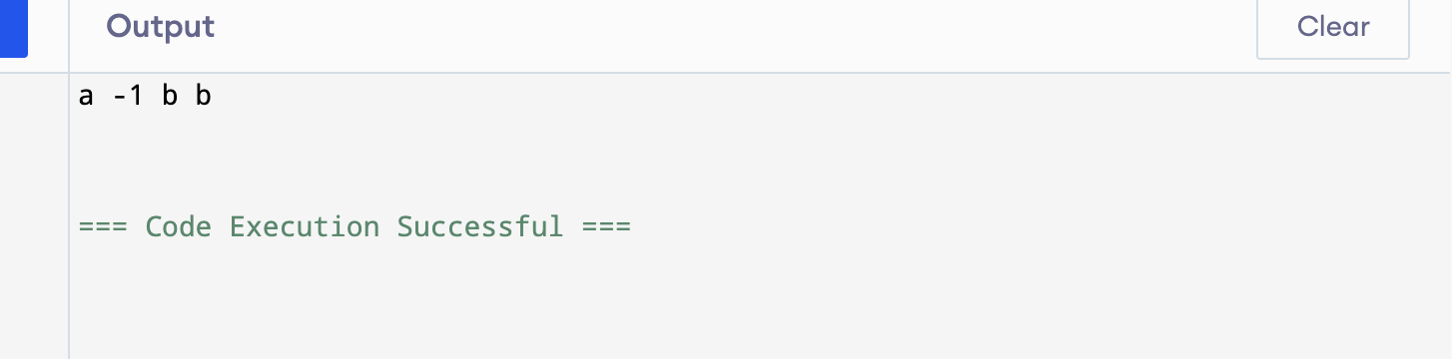

Question5:
